FAQ

What is Blackboard Connect?

What is the Blackboard Connect™ service?
The Blackboard Connect™ service allows authorized civic leaders to create and rapidly disseminate time-sensitive
messages to every telephone number stored in the notification database. With the Blackboard Connect™ service,
authorized users can send thousands of messages in minutes. Only authorized officials are allowed access to the
system.

How does the service work?
Authorized officials record a voice message that is then delivered quickly to individual phones in the notification database.

What types of messages will be sent using the service?
Any message regarding the safety or welfare of our community would be disseminated using the Blackboard Connect™
service.

Examples would include severe weather warnings and updates, hazardous traffic or road conditions inside the town or
affecting local routes, and any other situation that could impact the safety, property, or welfare of our citizens.

Does the Blackboard Connect™ service replace other systems that have been used to provide time-sensitive
information to residents?
This system is a significant enhancement to existing means of communication and is supplemental to, not a replacement
for, the systems we have used in the past.

The call-in emergency information line (XXX)-XXX-XXXX, which is activated during an emergency situation, will still be
available. Also, TV, radio and our town web site will continue to broadcast important announcements.

Is my telephone number included in the notification database?
It is our intention and hope that every residence and commercial facility in our community be included in the notification
database. For businesses, we only store one main phone number. For residents, we may have more than one number
that belongs to you in the database. Additionally, you may request to have a secondary number be entered into our
database for priority calling.

Can I use a cell phone as my notification database listing?
Yes, we can accept cell phones as secondary phone numbers in the database and encourage you to request that your
number be included.

What precautions are being taken to protect personal information?
Blackboard Connect™™ is a service of The NTI Group, Inc. (NTI). NTI takes security and privacy concerns very
seriously and does not sell, trade, lease or loan any data about our clients to any third party. From a technical
perspective, we utilize multiple physical and virtual layers of firewalls to maintain data security. NTI only utilizes secure
transmissions with its customers. No confidential information is ever transmitted between NTI and its customers using e-
mail or FTP, but rather always utilizes either a VPN tunnel or SSL. Data is hosted in state-of-the-art facilities which
require photo identification, thumb-print recognition, keyed access, and are manned 24/7 with full-security personnel. All
data is encrypted prior to being placed on tape for offsite storage. NTI also retains an external, independent security firm
to perform annual security audits.

1

blackboard.com/connect
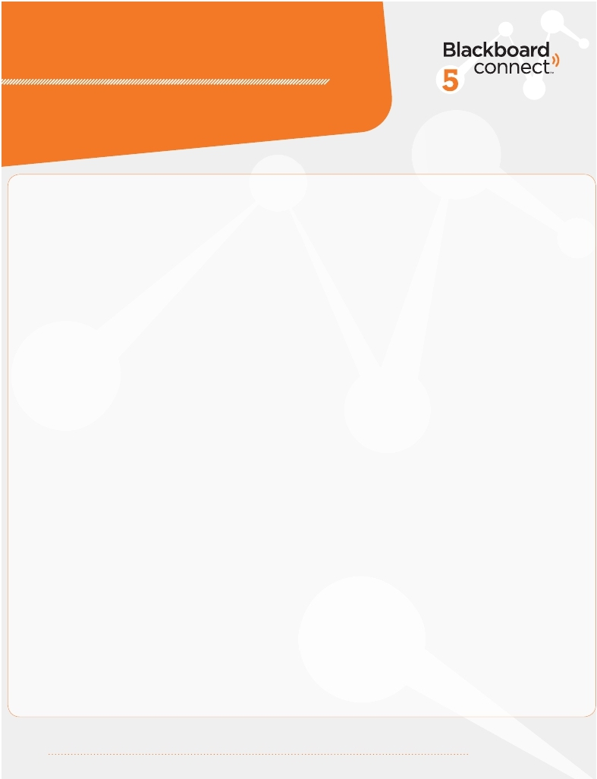

!
Will there be a way to positively identify incoming calls made by the town using the system?
The caller-ID number for calls generated by the Blackboard Connect™ service will be the same as the Town Office
number: (XXX)-XXX-XXXX. In addition, every message will begin with the same standard announcement: “Hello, this is
Chief ______ calling with an important message from the Town of _______”. The message content will follow this
standard introduction.

Will the Blackboard Connect™ service work if I have a call screening system on my phone?
There are several varieties of call screening devices that use differing protocols for screening. In general, the system has
been found to work with these devices. However, some may require some type of pre-programming to allow our town’s
telephone number to pass through. We may conduct periodic test to assure that messages are being delivered to
numbers in the notification database.

If I am a non-resident home or condominium owner, what phone should be listed in the notification database?
For non-residents or owners who reside out of our town/city, you may provide an additional phone number to be included
in our database to contact during certain situations. In general, calls are sent to the primary number only, but we also have
the ability to call multiple numbers for each resident or business when requested by the resident or business. Please
contact our town hall office at (XXX)-XXX-XXXX to provide us with that information.

If I have provided more than one phone number, when will they be called?
Should a situation arise that requires us to contact you at multiple phone numbers, we can activate the system to place a
simultaneous call to all of your numbers. In most cases, we will be sending calls only to one phone number.

My primary phone or my second listing is a cell phone with a non-local area code. Will the Blackboard Connect™
service call numbers outside the area?
Yes. The area code does not impact whether or not a call is made.

How does the Blackboard Connect™ system respond to busy signals or no-answer situations?
For busy signals, the call will be repeated several times in an attempt to reach you. The same is true for No-answer and
Call-waiting. If a message recorder answers the call, the message will be left on the answering device. If, after several
attempts the call does not successfully go through, the system will stop attempting to call.

I am receiving town notification calls at my fax or my secondary phone line. Can I switch to have the system call
my primary phone number?
Yes. Please contact us at (XXX)-XXX-XXXX to change the phone number in our notification database.

I was not able to listen to the entire call. Is there a way to repeat the message?
Yes, at the end of the message playback, simply press the star (*) key on your telephone to have it repeated in its entirety.

I answer the phone but the “Hello” message repeats. It then hangs up,
calls back, and the same thing happens again. How can I hear the entire message?
Repeating or looping of messages happens when the system detects excessive noise in the background, which is caused
by loud radio and television volumes, people talking near by, or busy traffic noise. When you receive the next call, say
“hello” once and turn down the volume of your radio/television or press the mute button on your telephone to allow full
message delivery.

2

blackboard.com/connect

